we have understood how to read the financial statements. We will now focus our attention on analyzing these financial statements. The best way to analyze the financial statements is by studying the ‘Financial Ratios’. The theory of financial ratios was made popular by Benjamin Graham, who is popularly known as the father of fundamental analysis. Financial ratios help in interpreting the results, and allows comparison with previous years and other companies in the same industry.

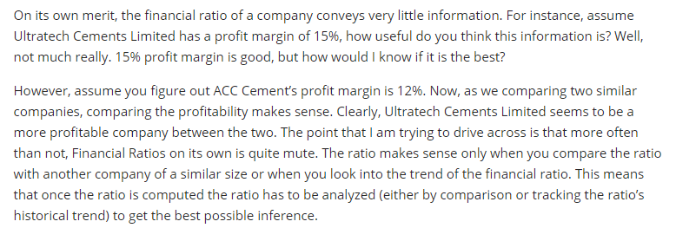

**The Financial Ratios**

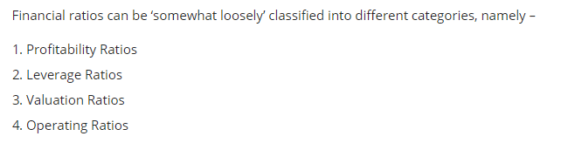

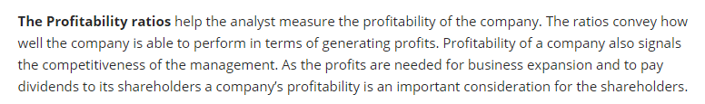

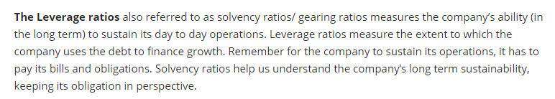

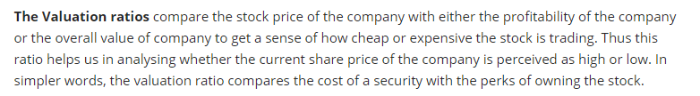

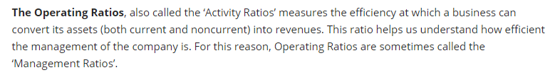

## The Profitability Ratios

## EBITDA Margin (Operating Profit Margin)

EBITDA Growth (CAGR)

## PAT Margin

PAT Growth (CAGR)

* **Return on Equity (ROE)**
* **Return on Asset (ROA)**
* **Return on Capital Employed (ROCE)**

## 

## 

## 

## 

## EV/EBITDA ratio

## 

## 

## In order to buy this company you have to give 8 times

## 

## If EV/EBITDA exists between 6-10, its optimum time to buy.

## 

## From Forecasted EV , we should subtract debt in mar2018, to get effective Forecasted EV. Here hero don’t have debt hence nothing deducted.

## dividing the the Current Market Capital with the shares current price. you would get the Shares outstanding Number.﻿

## We can use EV/EBITDA model to get TARGET PRICE in future.

## Entry price is the time in market to buy(since cagr we are expecting will remain same for next 5 years or 1 year at 7.82, which may not remain, its better to find 2/3rd of target price, this is price at which to buy . The 2/3 Margin of Safety is taken because we might over estimate the target price. Hence, as the name implies a Margin of Safety is taken so that even if we over estimate the target, we should enter the stock in a range from which there is a lower chance of further downside.

## 

## 

## 

## 

## 

## 

## 

## 

## 

## 

## 